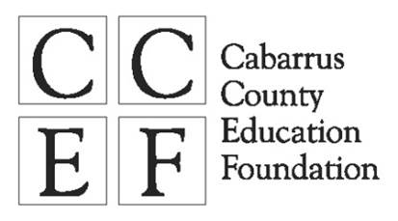
Classroom Grant Application

DEADLINE FOR GRANT SUBMISSION: DECEMBER 6, 2019
Program Goal: The Classroom Grant Program seeks to reward CCS teachers who are innovative in their approach to teaching by providing resources not available through normal school funding. Some students choose to pursue careers that allow them to make a very good wage with less expensive education options. Students who go into occupations after attending technical school or community college can earn salaries that are higher than students who attend a four-year university. This grant targets learning opportunities that shine a light on these types of fulfilling careers that can be achieved without a four-year college education.
Grant Eligibility
This grant is available to staff at all CCS middle and high schools. Grants must directly impact students’ learning and preference is given to staff involved in curriculum delivery.
CCEF Grant Available
Ellis Jewelers Career Exploration Classroom Grant funds one opportunity up to $600 to introduce students to pursue careers that do not require a college degree and allow them to be make a very good wage, with less expensive education options. This grant is available to middle and high school educators only. Preference will be given to those that promote skilled trades.
Grant Requirements
- All funds must be used during the 2019-2020 school year. Grant funds are made payable to the school and are given during an award presentation prior to December 19, 2019.
- Submit pictures and/or video that represents the grant in action.
- Submit a final report by May 29, 2020 on Google Docs form. Link will be emailed at a later date.
- Acknowledge CCEF classroom grant awards in notice to parents of children who will benefit and submit a copy of communication to CCEF.
- If requested, must schedule a classroom observation with the Cabarrus County Education Foundation to see the grant in action by notifying the Executive Director two weeks in advance.
Grant Expectations
- When posting announcements regarding CCEF classroom grant awards on social media posts, please remember to tag CCEF and capture it to send in an email to CCEF.
Grant Guidelines
- If you are requesting equipment or technology, be sure to have a creative project to correspond with the items requested.
- Grants funds may be used to purchase materials and items from any source. Use of “State Contract” is not necessary.
- Keep in mind that if you receive a grant and then transfer to another CCS school, your principal has the discretion to decide if equipment purchased with your grant remains with the school or you.

Application Procedures
- Grant applications must be complete and submitted to the Foundation no later than 5:00pm on Friday, December 6, 2019.
- All questions on the application must be answered. If you are applying for one of our special grants, please complete the corresponding addendum page in addition to the regular application questions.
- All applications must have the signature of the principal in order to be considered complete.
- Submit application via email, mail, CCS Courier, or delivered to Amy Gough via:
Email: Amy.gough@cabarrus.k12.nc.us
Mailing Address: Cabarrus County Education Foundation, PO Box 388, Concord, NC 28026
CCS Courier: Cabarrus County Education Foundation – CCS Education Center
Deliver: 4401 Old Airport Road, Concord NC 28025
Application Guidelines
- Applications MUST be legible and easy to understand. Please proofread.
- Applications that are detailed and well-written are more likely to be funded.
- Please avoid the use of acronyms or write out the acronym in parenthesis after its first use.
Grant Evaluation
Grants are reviewed by the selection committee which may be comprised of the following: Deputy Superintendent for Curriculum & Instruction, Director of Career Technical Instruction, Director of High
School Education, Director of Middle School Education, other CCS Staff, Education Foundation board members and community members.
Each application will be evaluated on the criteria outlined in the attached rubric. The Ellis Jewelers Career Exploration Classroom grant has an additional criteria outlined.
Grant Awards
You may receive full or partial funding if your grant is selected. Grant recipients will be notified no later than December 19, 2019. Grant monies will be written to the school and presented during an awards presentation to be held at your school.
Questions or Further Information
Contact Amy Gough at amy.gough@cabarrus.k12.nc.us or 704.260.5608.

CCEF CAREER EXPLORATION
CLASSROOM GRANT APPLICATION
SPONSORED BY ELLIS JEWELERS

PROJECT INFORMATION

I am applying for the following CCEF Classroom Grant(s). Please refer to application guidelines and full descriptions of each specific category in the grant guidelines or on the CCEF website, www.ccefnc.org.
□ Ellis Jewelers’ Career Exploration Classroom Grant

Project Title:
Lead Applicant Name:
Date Submitted:
School:
School or Department Address:
School Telephone Number:
E-­‐mail Address:
If team request, please list the other team members:

I understand that the awarding of all grants and the amount of any grant shall be at the discretion of CCEF and its Classroom Grant Selection Team. I further understand that, in the event I am awarded a grant for the project described here, CCEF shall have the rights to publicize this grant including a description of the project, photos and videos of the grant in action, and results of the project. I have read and agree to abide by all guidelines and requirements of this grant.

Applicant’s Signature Date

I have reviewed and support the application of this grant.

Principal’s Signature Date

PROJECT OVERVIEW

Project Title:

- How many classes/sections will participate in this classroom project?
Note: A classroom is considered a section of different students that you teach/utilize the grant with. A club is considered one classroom unless you utilize the grant with more than 1 group of students.
- Approximately how many students will participate in this classroom project this year?
- What type of project is this?
□ Tactical – majority of materials purchased will be consumed during the 2019-20 school year
□ Legacy – majority of materials purchased are reusable after the 2019-2020 school year
- Provide a brief descriptive summary of the classroom grant.

- Describe the population to be addressed by this grant including grades impacted and demographics.

DETAILED PROJECT INFORMATION

- Describe the need that this grant will meet.

- Describe the type of skills students will learn from the project experience and how the skills relate to life application.
For example, through the project students will apply engineering skills to build bridges. Math skills, critical thinking and problem solving skills will also be required to successfully build the bridge.

DETAILED PROJECT INFORMATION (cont.)

- Describe how this project enhances the curriculum including how the project is creative and innovative and if the outcomes are prescriptive or student-driven.

- Describe the CCS educational standard(s) that the project will support.

DETAILED PROJECT INFORMATION (cont.)

- State the major objectives of the project and how you will determine whether your project successfully met your objective(s).

- What will happen to the project at the conclusion of the grant? In what ways will the project be shared with other students and/or educators?

PROJECT BUDGET AND FUNDING

- To fully implement the project, what is the total overall project budget? $
- What amount are you requesting from CCEF as part of this project (max. $750)? $
- Will additional funds besides this grant be used for the project? □ Yes □ No

If yes, please indicate where the additional funds will come from to complete the project:
Source of funds | Funding commitment received (Y/N) | Cost
Cabarrus County Education Foundation (requested amount) | N | $
 |  | $
 |  | $
 |  | $
Total Amount of Funds  (should match amount of total project budget in question #1) |  | $

BUDGET AND FUNDING (cont.)

- Total Project Expense (provide an itemized list of items to be purchased for the overall project)
Check items to
be purchased
Items to be Purchased Quantity Cost with CCEF grant
 |  | $
 |  | $
 |  | $
 |  | $
 |  | $
 |  | $
 |  | $
 |  | $
 |  | $
 |  | $
 |  | $
 |  | $
 |  | $
 |  | $
 |  | $
 |  | $
 |  | $
 |  | $
 |  | $
 |  | $
 |  | $
 |  | $
Total Cost of Project (should match #1) |  | $

Career Exploration Grant Specific Questions

- What trade(s) will the project expose students to?

- The project will introduce students to: (check all that apply)
□ Introduce career possibilities in the trades
□ Increase knowledge about career opportunities in the trades
□ Expand students’ understanding of career opportunities and the link to sustaining them as adults
□ Build career skills utilized in the associated trade(s)
□ Provide an opportunity to promote their skills, both technical and soft, in a life-like setting
□ other (please describe)

- Describe how the project will support the selected objectives in question 2.

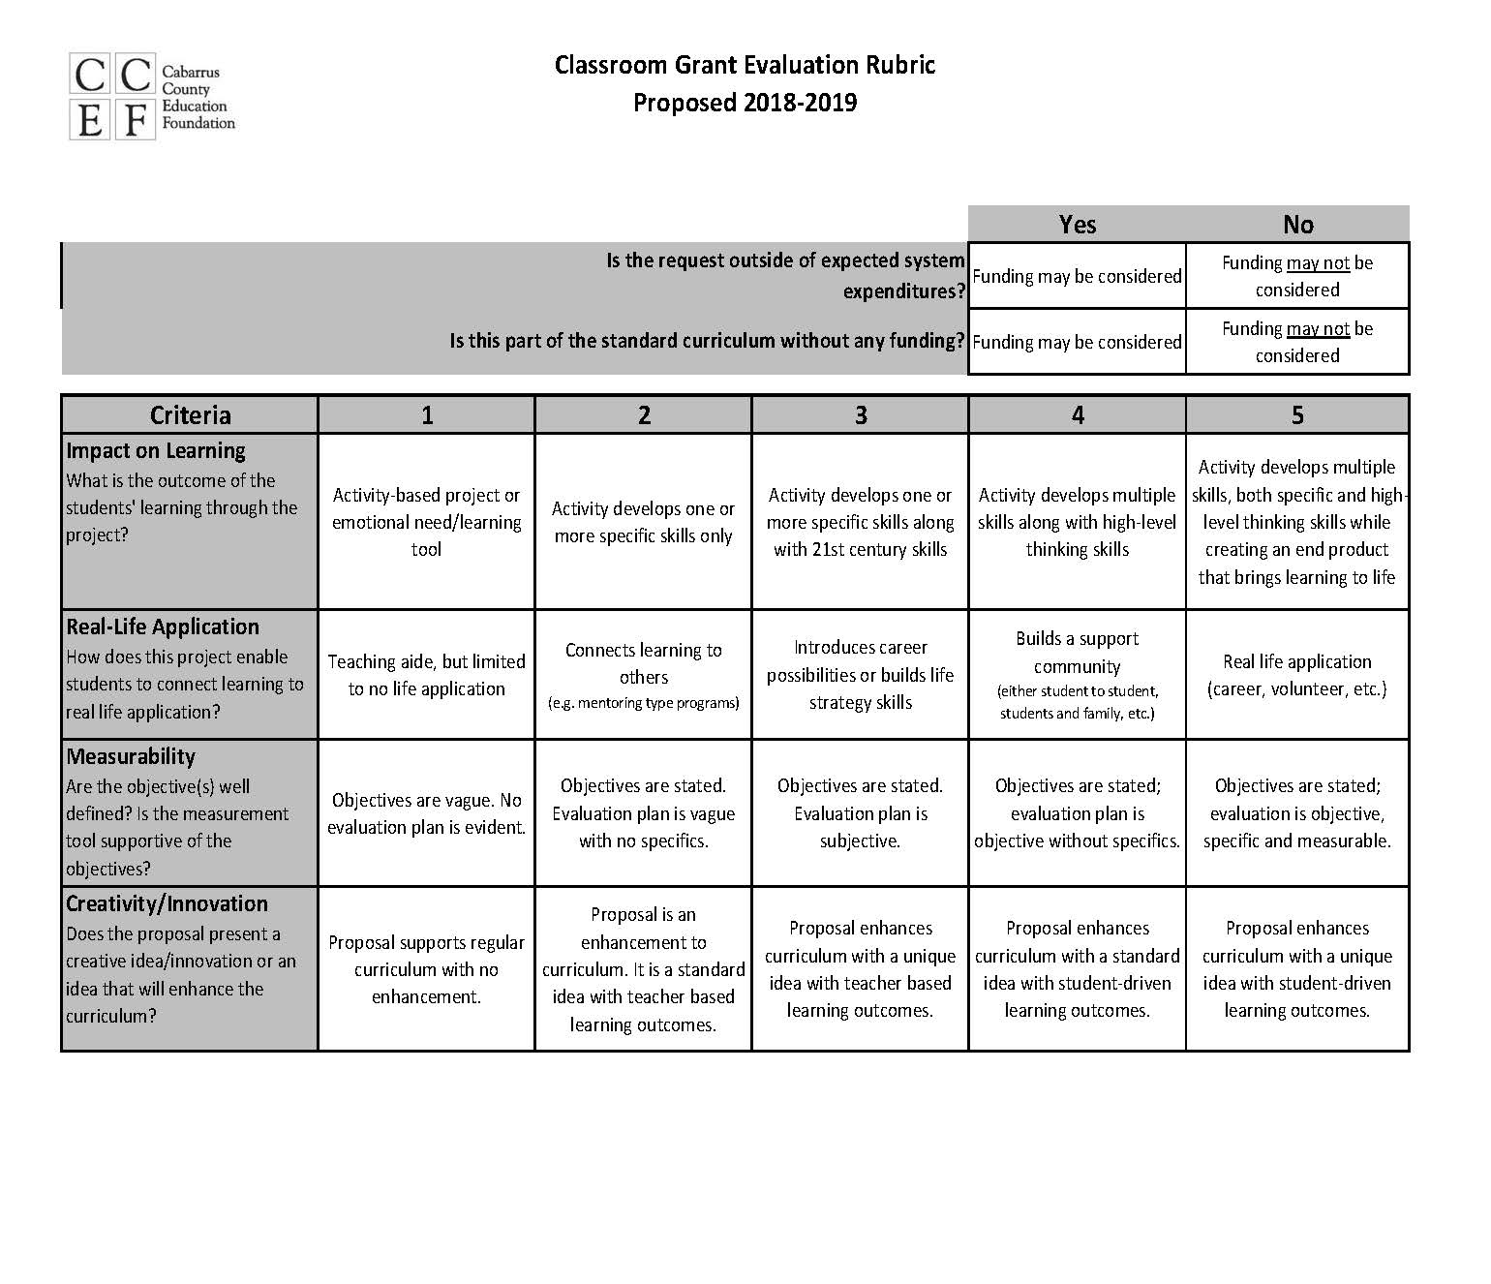

2019-2020

